**Exercise 1**

For velocity = 2 , The controllability and observability of the system are:

Rank of P is: 4

The system is **controllable**

Rank of Q is: 4

The system is **observable**

For velocity = 5 , The controllability and observability of the system are:

Rank of P is: 4

The system is **controllable**

Rank of Q is: 4

The system is **observable**

For velocity = 8 , The controllability and observability of the system are:

Rank of P is: 4

The system is **controllable**

Rank of Q is: 4

The system is **observable**

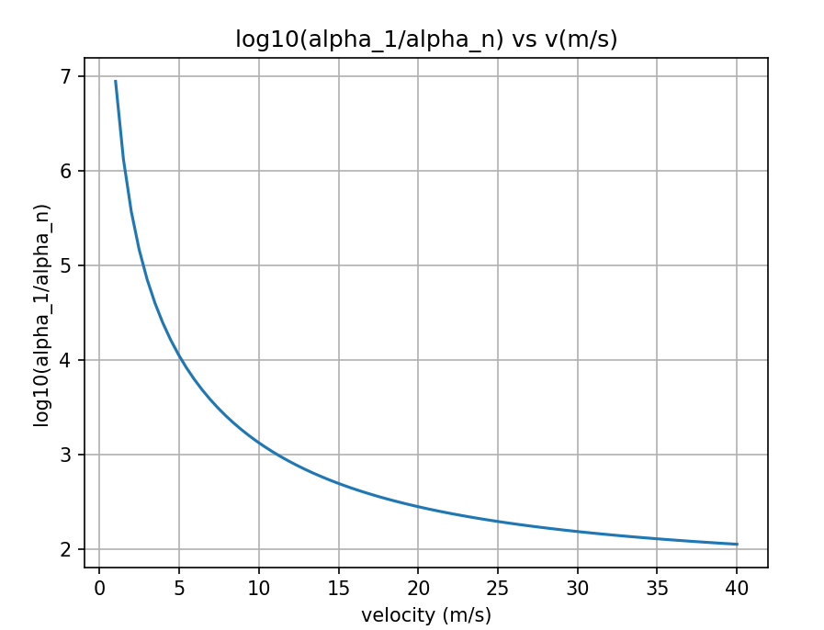

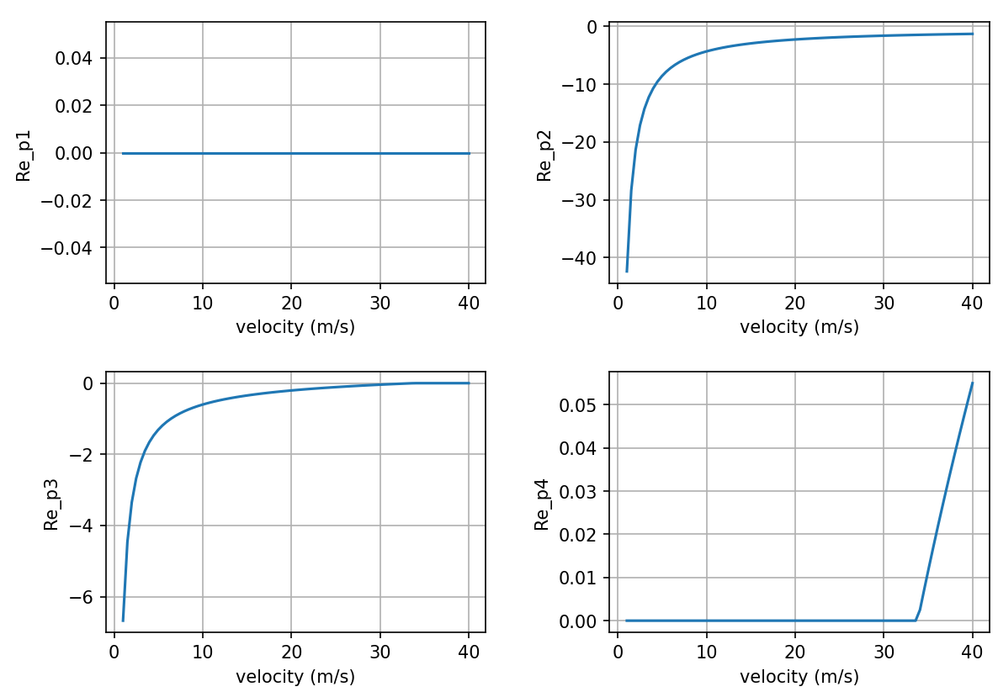

From the plots above, one can found that as the velocity increase, the system’s controllability increases and stability decreases, which means the system is further sensitive to small perturbations, and from the Re_p4, we can see that the controllability continually increases until some specific velocity, and after that velocity the system become unstable even with zero input.

**Exercise 2**

Score for completing the loop: 30.0/30.0

Score for average distance: 30.0/30.0

Score for maximum distance: 30.0/30.0

Your time is 81.44

Your total score is : 100.0/100.0

total steps: 81440

maxMinDist: 4.9606087083385235

avgMinDist: 0.6589714338454759

